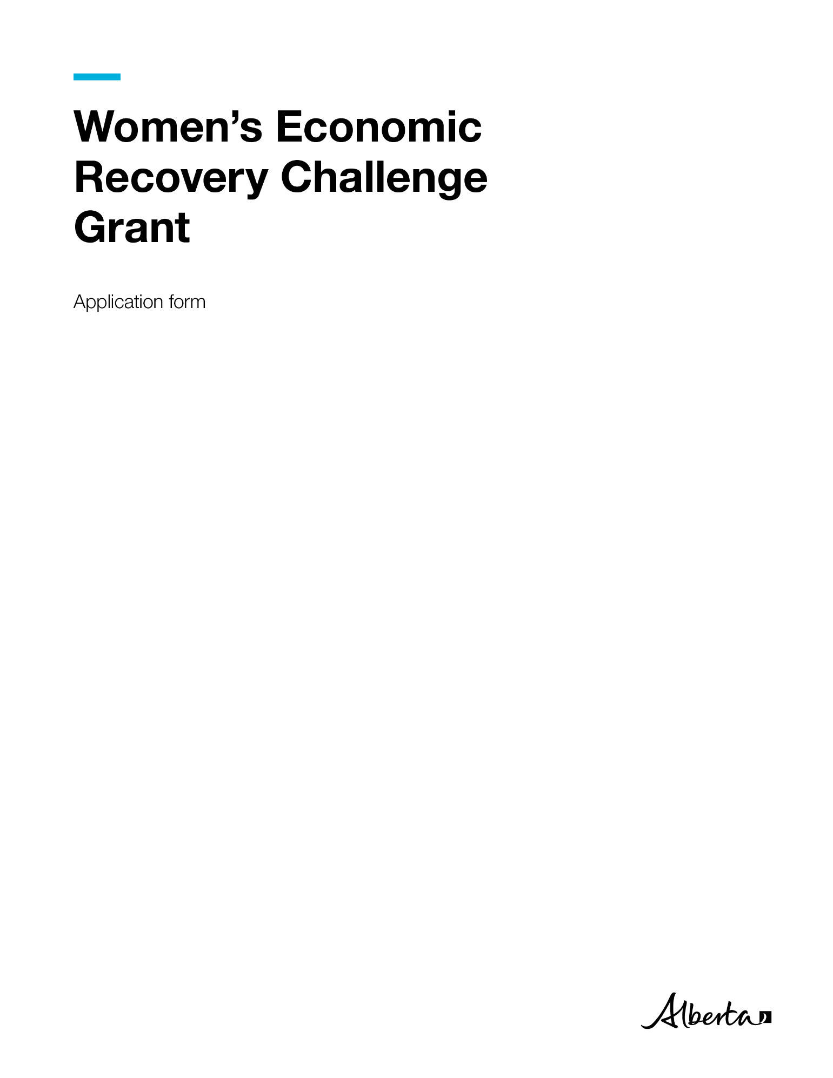

|  |  |
| --- | --- |
| **Women’s Economic Recovery Challenge Grant**  **APPLICATION FORM** | |
| **[Insert Organization's Name]: [Insert Project Title]** | |
| **Applying Organization** | **Responses** |
| Operating Name: |  |
| Legal Name: (if different than above) |  |
| Type of Organization: | community organizations  municipalities, including municipal districts  First Nations or Metis Settlement  industry associations  economic development organizations  other, please explain: ___________________ |
| Legislation Organization is Registered Under: | Non-profit registered under a special act or a private act of the Alberta legislature  Non-profit registered under part 9 of the Companies Act (Alberta)  Society registered under the Societies Act (Alberta) or Agricultural Societies Act (Alberta)  Cooperative registered under the Cooperatives Act (Alberta)  other, please explain: _____________________ |
| Corporate Access Number (or other in connection to above category): |  |
| Organization Incorporation Date: |  |
| Business Address: (delivery address that accepts couriers) |  |
| City/Town: |  |
| Postal Code for Business Address: |  |
| Mailing Address: (if different than above, include postal code) |  |
| City/Town: |  |
| Postal Code: |  |
| Organization Website: (if applicable) |  |
| **Proposed Project** | **Responses** |
| Project Title: |  |
| Amount Requested: |  |
| Start Date: (should appear as Day, Month, Year, for e.g. 4 November 2020) |  |
| End Date: (should appear as Day, Month, Year, for e.g. 23 April 2021) |  |
| Total Project Duration (in months): |  |
| **Applicant Contact Information** | **Responses** |
| Name of Primary Contact: |  |
| Job Title: |  |
| Direct Phone Number: |  |
| Direct Email: |  |
|  |  |

|  |  |
| --- | --- |
|  |  |
| Women’s Economic Recovery Challenge Grant Organization Name: [enter here]  Use Arial black font, size 12  Maximum page count (not including attachments): 15 pages | |

# Program Outcomes

Which Challenge Grant outcome does your project **best align** with?

Increase women and girls representation in STEM.

Increase women and girls representation in entrepreneurship.

Decrease barriers women face in the workplace.

Foster ease of women’s career transitions, employment skills and labour entry or re-entry.

# Executive Summary

Please provide a 150-word summary of the proposed project. Information provided in this summary will be publicly available through Government of Alberta channels.

# Project Description

In this section, describe your project and answer the following questions. Provide details to all questions that align with the proposed project:

1. What is it that you intend to do in this project? (e.g. description of activities you intend to provide, including how and when they will be delivered)
2. Please provide specific outcome measures to demonstrate how you will achieve your projects Challenge Grant outcome (per Program Outcomes identification in section A of this Application Form).

|  |  |
| --- | --- |
| **Quantitative Results**  (# and % change in target population) | **Qualitative Results**  (themes, patterns, cases) |
|  |  |
| … add rows as necessary |  |

1. Describe how the project will make a unique and positive impact on the ecosystem of supports available for Albertan women and girls, beyond an individual community or organization.
2. Does the project target Indigenous communities?
3. Does the project leverage financial supports beyond Challenge Grant funding requested?
4. Describe how your project design takes into account intersecting identity factors of the beneficiaries. Examples include gender, age, education, language, culture, income and geography.

***Recommended length: 3-5 pages***

# Ability to Deliver

In this section, provide:

1. Overview of your Organization
   1. Provide an overview of your organization’s mission and goals.
2. Knowledge and Experience. Describe your organization's:
   1. Expertise in delivering community-based supports for economic growth.
   2. Background, knowledge, experience and current capacity to deliver this project.
3. Project Roles and Responsibilities
4. Provide a list of the positions involved in the project delivery. This should include the position, titles, and key responsibilities.
5. Commitment to Diversity
   * If your organization has a formal diversity and inclusion statement, please provide an excerpt.
   * If your organization does not have a formal diversity and inclusion policy, please indicate your commitment to implement projects in such a way that respects diversity, promotes an inclusive society, and supports anti-racism.
   * For an example, visit: [*https://www.alberta.ca/diversity-inclusion-policy.asp*](https://www.alberta.ca/diversity-inclusion-policy.asp)

***Recommended length: 2-3 pages***

# Risk Management

In this section, complete the Risk Management table:

* + Identify and describe all risks to the success of the project delivery
  + e.g. How will you deal with sudden interruptions to project activities or enforced social isolation?
  + Provide a detailed mitigation plan for your identified risks.

|  |  |  |  |
| --- | --- | --- | --- |
| **Identify Risk** | **Impact of Risk**  (on beneficiaries, deliverables and outcome) | **Likelihood of Occurrence** (Low, Medium, High) | **Proposed Mitigation Plan** |
|  |  |  |  |
| ...add rows as necessary |  |  |  |

# *Recommended length: 1-2 pages*

# Attachments

# Implementation Plan (download, complete and attach to application package)

* Budget (download, complete and attach to application package)

# Signed letter(s) from other funding source(s) or email from funder(s) acknowledging their funds for the proposed project, if applicable

# Up to two maximum signed reference letter(s) or email(s) speaking to the applicant’s knowledge and experience regarding the proposed project

# Organizational Chart and/or Staff List

Combined, the project application and attachments should **not exceed 25 pages.**